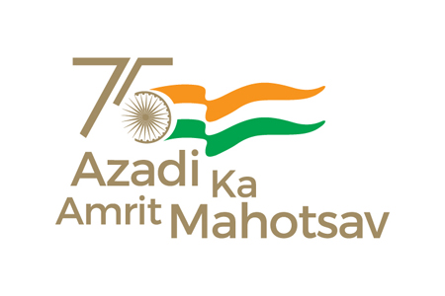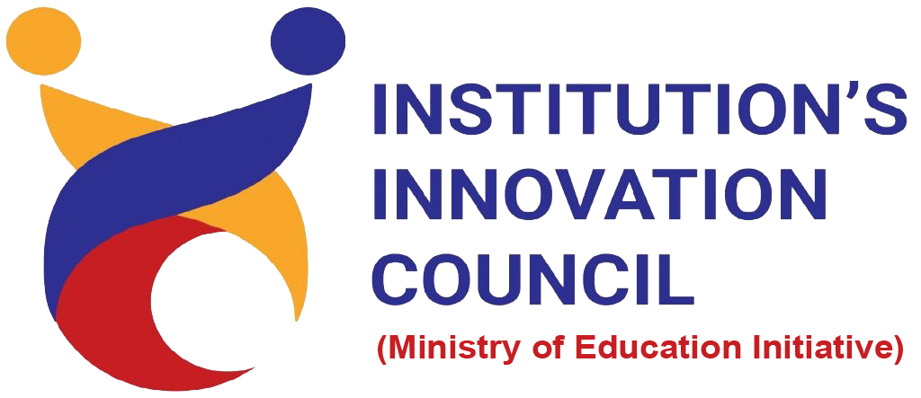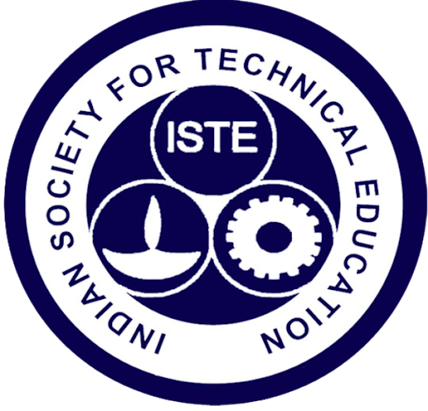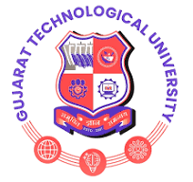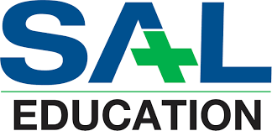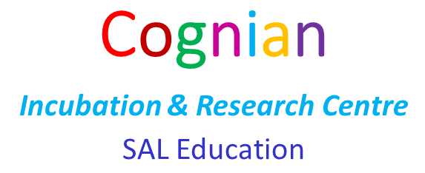

SAL Engineering and Technical Institute

A Report On

**A Series of Engaging Technical Sessions**

Under ISTE Chapter

***Webinars From:***

***TOPS Technologies***

*OrganizedBy*

CE, IT, CSE, ICT DEPARTENT

**SAL Engineering and Technical Institute**

**A Report on “A Series of Engaging Technical Sessions”**

**(5) Kotlin for Android**

**Date:** : 18th Oct, Friday

**Time**: 5:00 PM to 6:00 PM

**No. of Participants: 112**

**Learning Outcome:**

These webinars were very informative & interesting for our students. After completion of seminar students were able to:

* Learn basic concept of machine learning.
* Hands on Demonstrations of python.
* Working of various data sets.
* Emerging new technologies
* Software testing

**Workshop Glimpse:-**

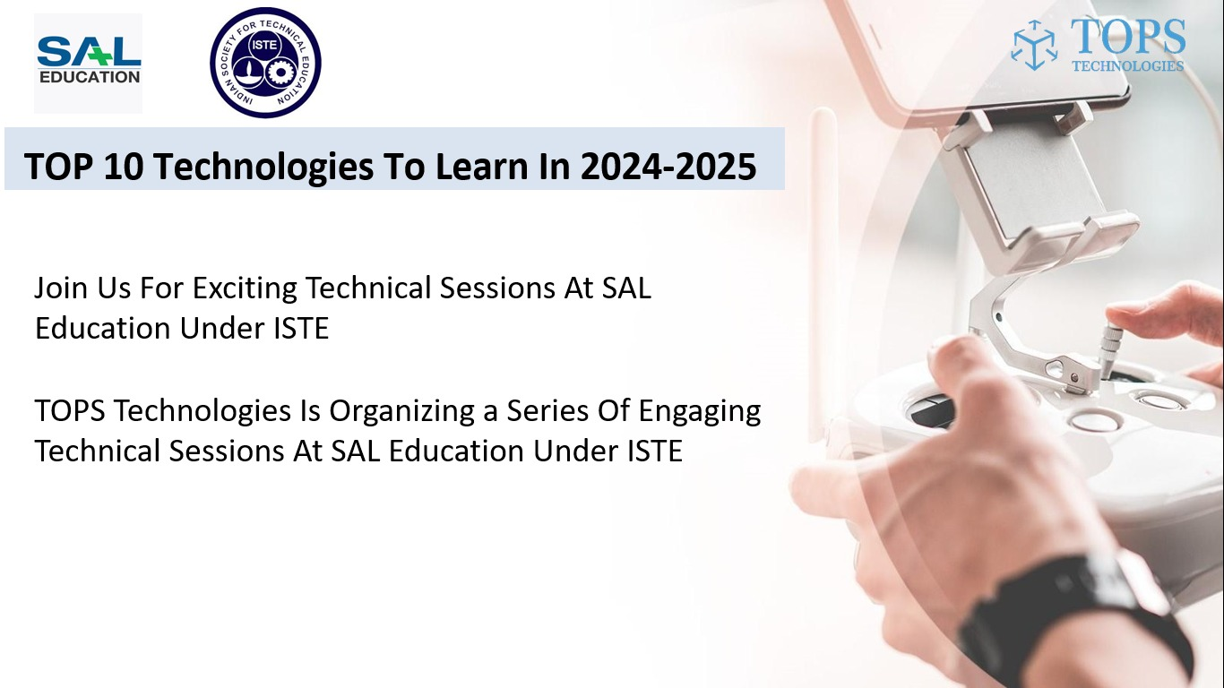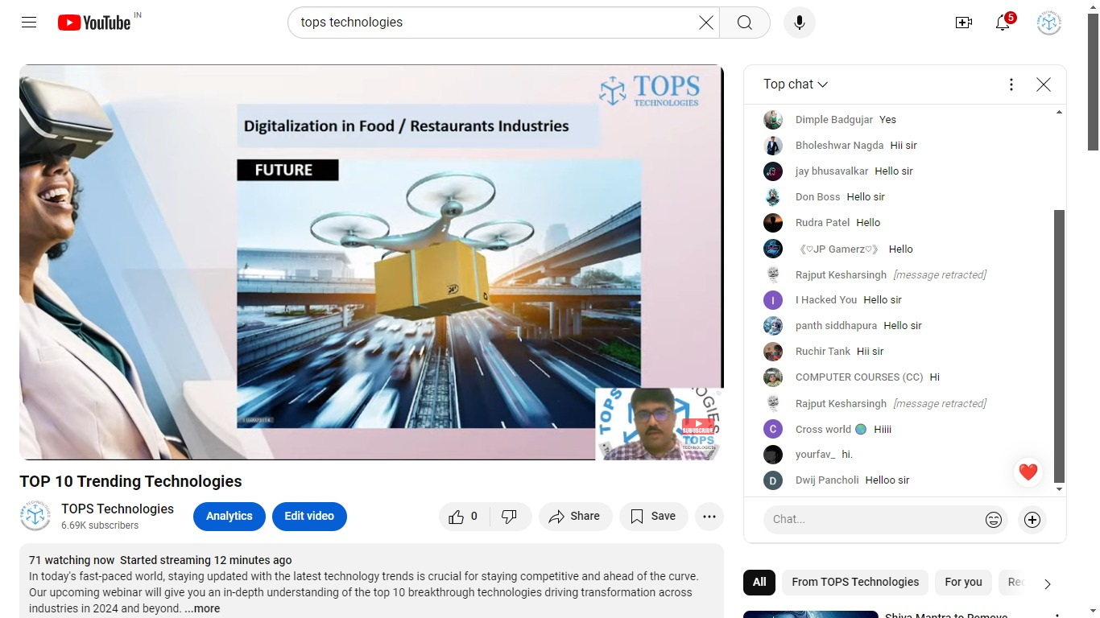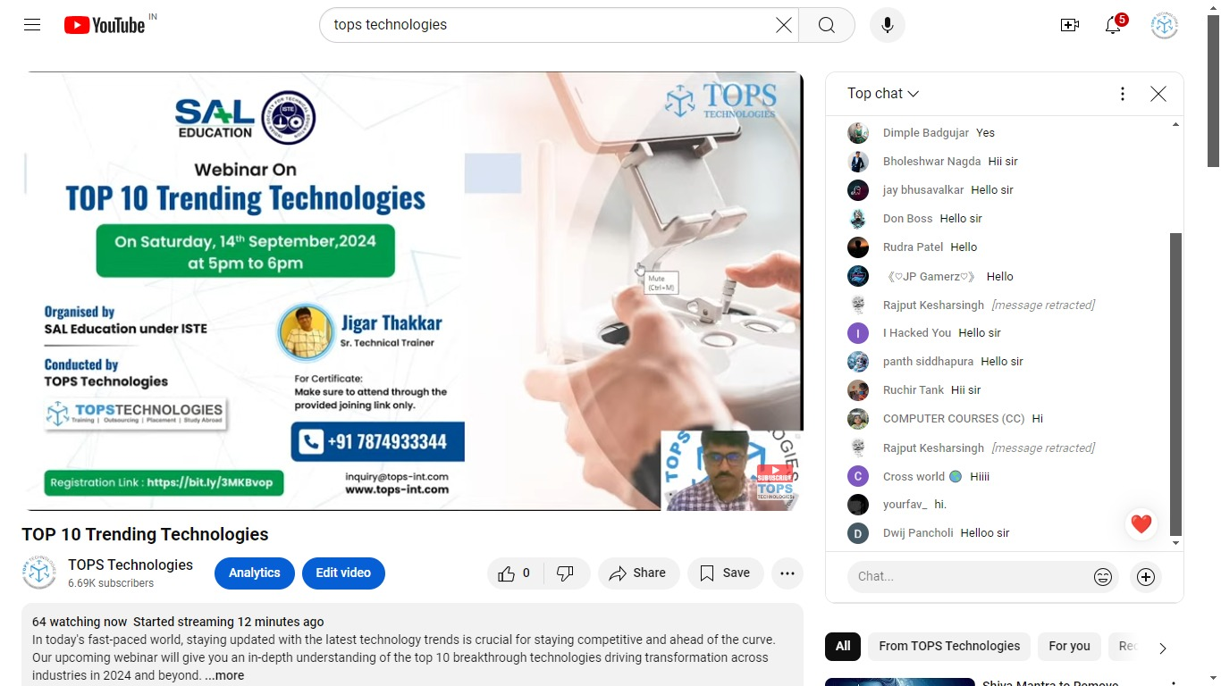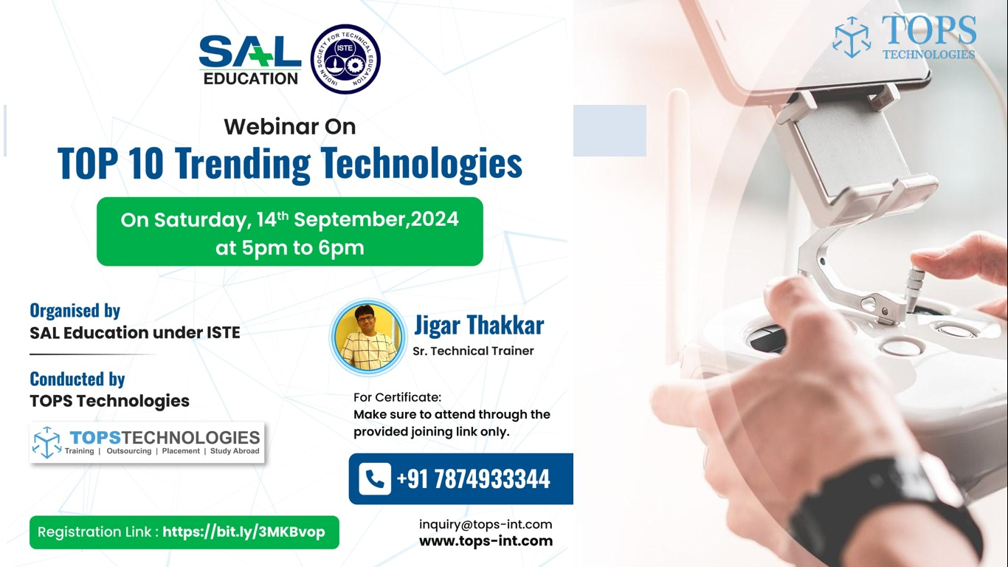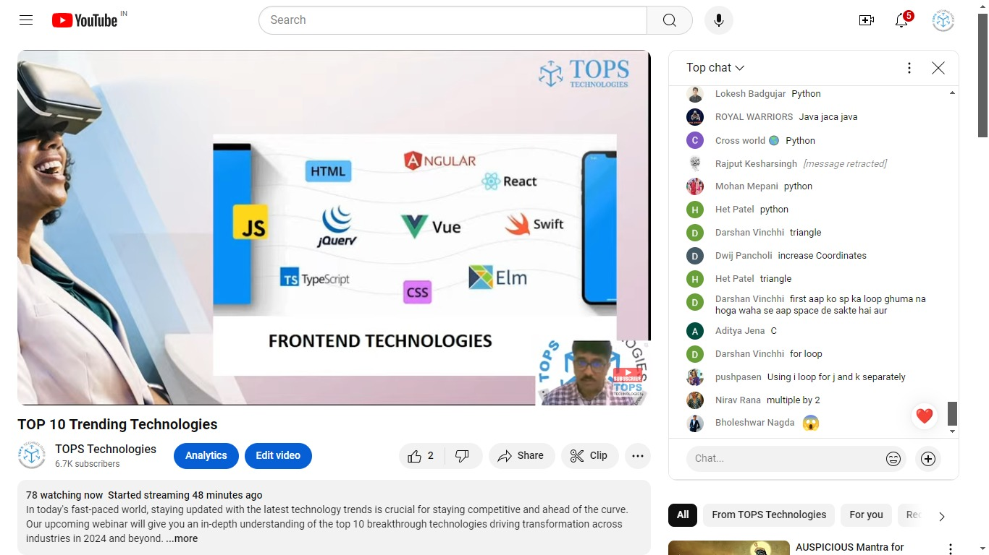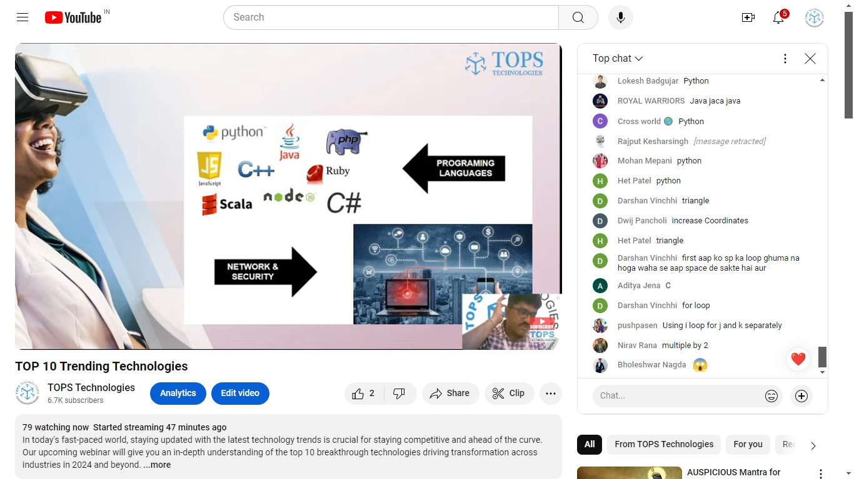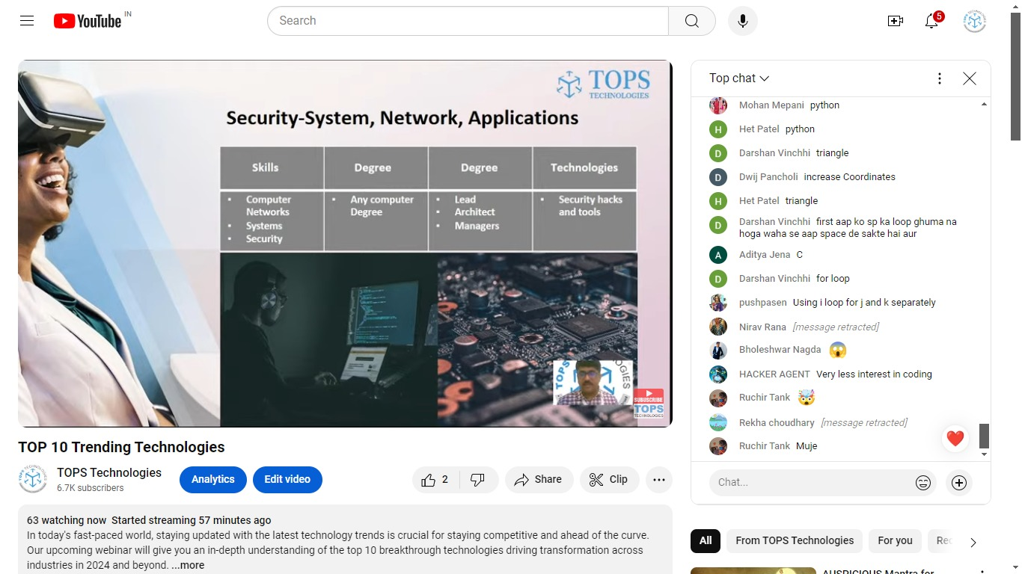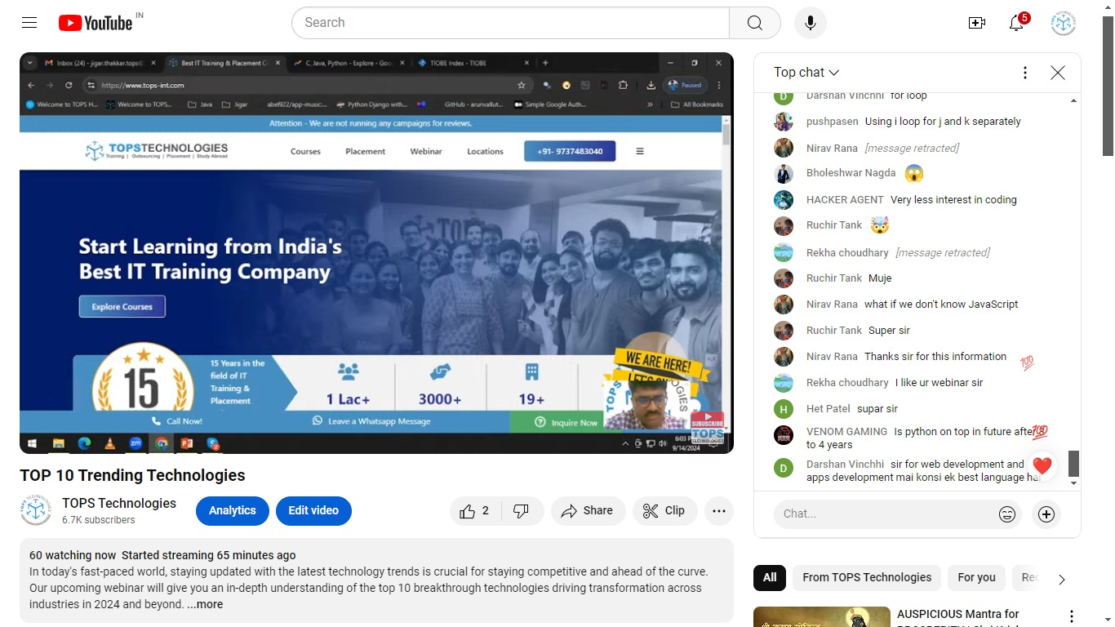

**Faculty Coordinator:**

Prof.Sachi Bhavsar